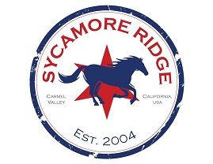
SYCAMORE RIDGE PTA
PTA General Association Meeting 8/10/2022

Called to order by: Sara Lake, PTA President at 9:35 a.m.
Date: Wednesday, August 10th, 2022

Attendance: Gregory Reade (PTA), Megan Scanderbeg (PTA), Sandy Tanaka (PTA), Sara Lake (PTA), KB Chen, (PTA), Priya Merrill (PTA), Kathy O’Neill (PTA), Bernard Peters (PTA).

President/Sara
- Welcome/call to order
- Approve 7/27/2022 PTA Meeting minutes

Treasurer/Lou
- Approval of Checks #XXXX-#XXXX
- Treasurers Report

Committee Reports
- Review 22/23 Budget (Lou)
Budget is tight. More worried about bigger items and food has become more expensive. Very unsure how much money will be brought in. For example, field day got expensive during covid.
Otherwise, PTA calendar and programs is approved.

- Outdoor staff lounge (Sara)
Would like to create a nice outdoor staff area with nice picnic tables, outdoor rug, etc. Need three tables. Probably need at least $2000, but maybe $2500. Laura Abrams is happy to help. We are carrying over $30k and we didn’t do a donation yet. The garden make over is a longer term project and all has to be approved by the district. This would be a fast project that could be implemented quickly and advertised.

Gregory moves to approve up to $2500 for an improved outdoor staff lounge. Sandy seconds it, all approve.

- Annual Giving Campaign Update (Sara / Sandy / Megan)
  - Levels
  - SWAG
  - Launch

Last year we did an event with Diesel. Owner was very enthusiastic about it and Mrs. Moore and Ms. Goode read there. Need to decide in September whether we are doing both or just one and then which one.
Logo: had a draft logo with Stallion in the middle of a circle. Gregory is finishing up with Logo. Sakura is interested in running spirit store.
For faculty membership: we are keeping it at $25 with a basic shirt.
Should we have a set up at Stampede to help people join there? Yes, we will have a table with spinner and swag give aways. Also had pictures with things like Gaga ball pit, etc.
- Back to School (Sara)
  - Hang banners (General Association Meeting, Welcome, AGC)
  - Chalk Decorations
  - Balloons
  - Volunteer Form (back to school nights)

- Stallion Stampede (Sara / Priya / Kathy)
  - DJ & Kona Ice – already booked
  - Balloon Twisting & tattoo needs to be booked.
  - Face Painting / Hair Spray (trying to get volunteers to do this & face painting)
  - Decorations? Maybe a banner? Previous decorations are not usable.
  - Volunteers
  - Hat contest and selling hats/bandanas ahead of time? Need to evaluate how many hats and bandanas we have. There was a hat judging contest with different categories and willing hats were on display. Winner got small gift card for each category. Would be nice to rotate sellers.
  - Pizza & Beverages: Fresh Brothers? Dominos? Need plates, napkins
  - Stallion reusable water bottles? Not in time for this event, but can consider offering cups.

- Drama Club
  - We need a parent to run this. Lex is interested and considering another person to help with sets/tech.

- New business?

- Update from Chelsea

Meeting closes at: 11:01m
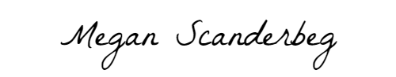
_____________________________________August 10, 2022_____

